AI Assisted Coding
Name: V.Tejaswini
Batch.no:24
Enroll.no:2503a52696
Lab2- Comparing three AI’s by giving prompt
Prompt: by using python generate a code which acts as simple calculator which perform add,sub,muiltipication and division
1)GITHUB Copliot 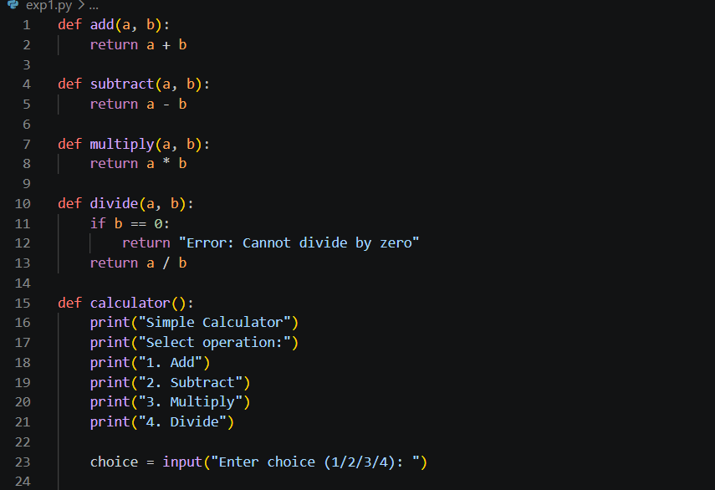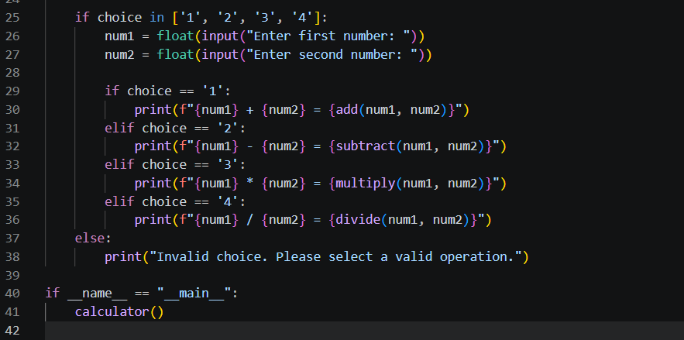
Output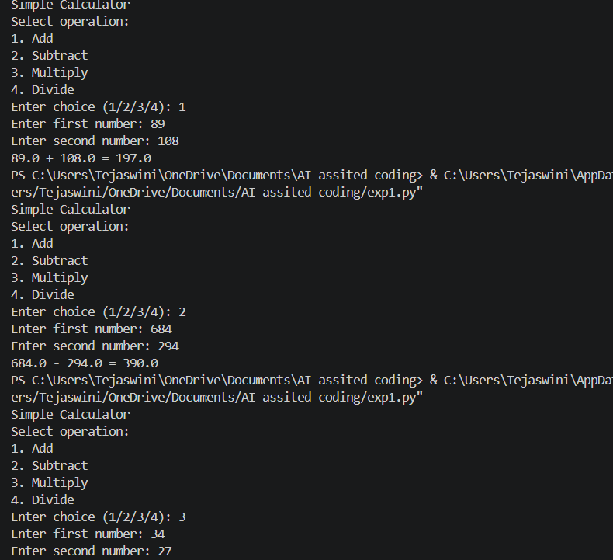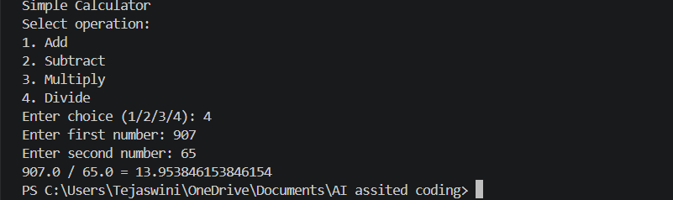

2)Claude.ai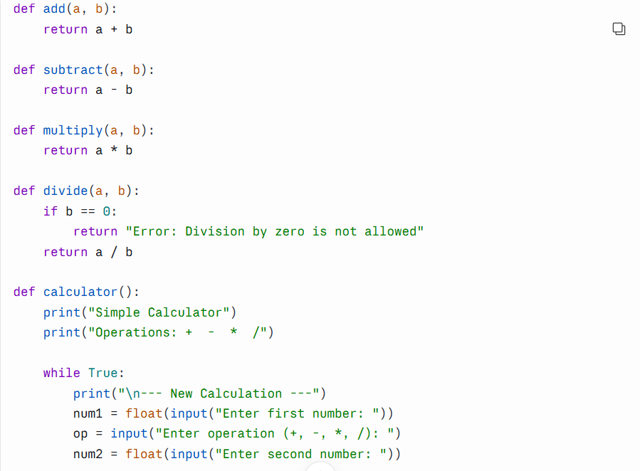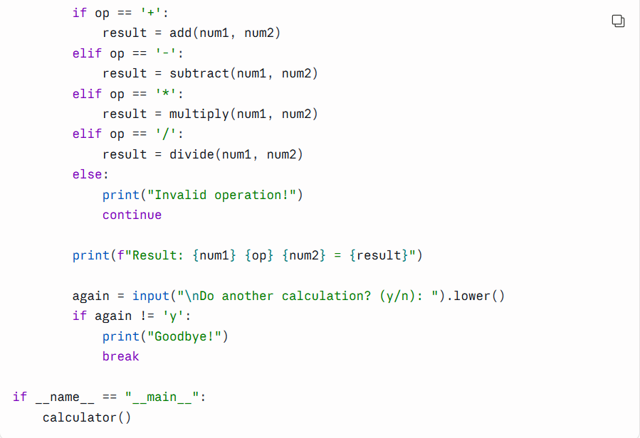
Output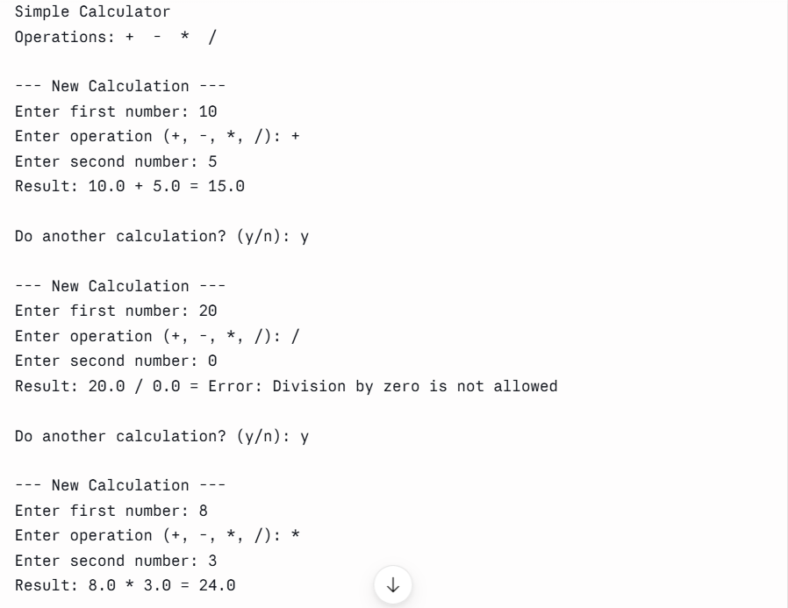

3)Google colab (gemini) 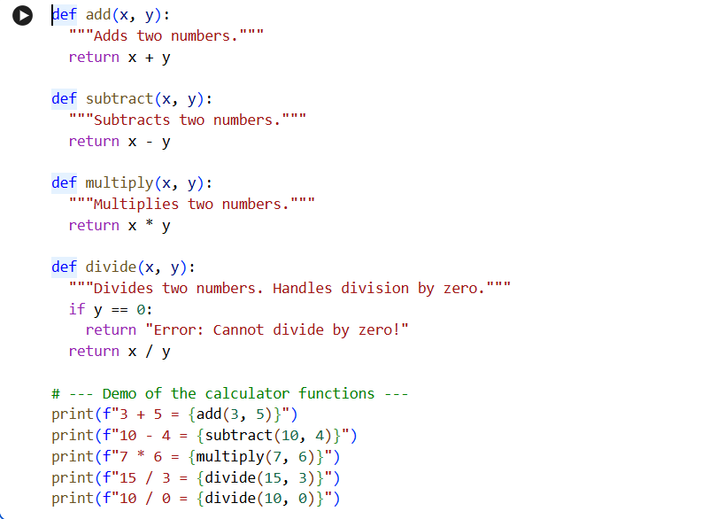
Output


Comparison of Three AI Coding Tools

The three AI tools compared were GitHub Copilot, Claude AI, and Google Colab.

GitHub Copilot: Generated clear and structured calculator code with separate functions. But the program was less interactive. The code needs to run again to perform other calculation.
Claude AI: Generated simple, user-friendly code with a loop that allows multiple calculations. It also handled division by zero properly. Its main drawback is that the code is slightly longer.
Google Colab: Generated short and easy-to-understand code. It is beginner-friendly and easy to run in Google Colab, but the given program requires changing the code to test different values.
Conclusion:
Among the three, Claude AI is the best for this task because its code is simple, interactive, and user-friendly.

